package com.itjluzh.hello;

import java.io.IOException;

import java.io.PrintWriter;

import javax.servlet.ServletException;

import javax.servlet.annotation.WebServlet;

import javax.servlet.http.HttpServlet;

import javax.servlet.http.HttpServletRequest;

import javax.servlet.http.HttpServletResponse;

@WebServlet(name ="helloServlet", urlPatterns= {"/hello.do"})

public class Hello extends HttpServlet {

protected void doGet(HttpServletRequest request, HttpServletResponse response) throws ServletException, IOException {

response.setContentType("text/html;charset=GB2312");

PrintWriter out = response.getWriter();

out.println("<html><body>");

out.println("<h2>您好，欢迎各位软件工程的同学。<br><br>Hello");

out.println("</body></html>");

}

protected void doPost(HttpServletRequest request, HttpServletResponse response) throws ServletException, IOException {

doGet(request, response);

}

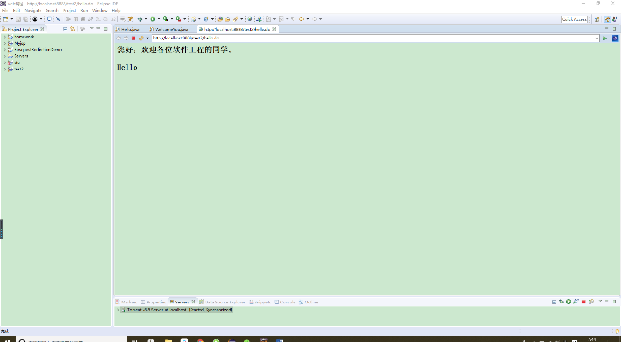

import java.io.IOException;

import java.io.PrintWriter;

import javax.servlet.ServletException;

import javax.servlet.http.HttpServlet;

import javax.servlet.http.HttpServletRequest;

import javax.servlet.http.HttpServletResponse;

public class WelcomeYou extends HttpServlet {

public void doGet(HttpServletRequest request, HttpServletResponse response)

throws ServletException, IOException {

String user = new String(request.getParameter("user").getBytes("ISO-8859-1"), "UTF-8");

System.out.println(user);

response.setContentType("text/html;charset=UTF-8");

String welcomeInfo = "Welcome You"+user+"同学";

PrintWriter out = response.getWriter();

out.println("<html>");

out.println("<head><title>欢迎页面</title></head>");

out.println("<body>");

out.println(welcomeInfo);

out.println("</body>");

out.println("</html>");

out.flush();

out.close();

}

public void doPost(HttpServletRequest request, HttpServletResponse response)

throws ServletException, IOException {

doGet(request,response);

}

}

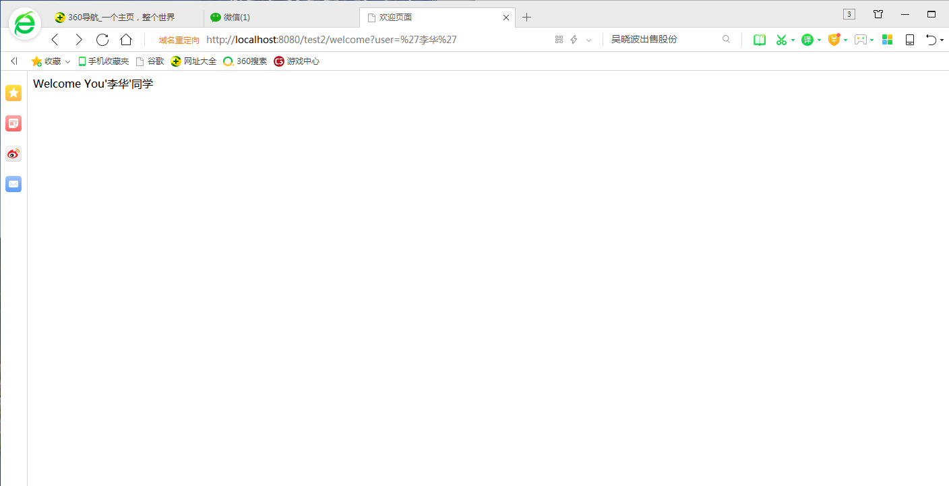

public class Register extends HttpServlet {  
 @Override  
 protected void doPost(HttpServletRequest req, HttpServletResponse resp) throws ServletException, IOException {  
 req.setCharacterEncoding("UTF-8");  
 String username = req.getParameter("user");  
 if (username != null && username.length() > 0){  
 req.getRequestDispatcher("success").forward(req, resp);  
 }else {  
 resp.sendRedirect("fail.html");  
 }  
 }

public class Success extends HttpServlet {  
 @Override  
 protected void doPost(HttpServletRequest req, HttpServletResponse resp) throws ServletException, IOException {  
 req.setCharacterEncoding("UTF-8");  
 String username = req.getParameter("user");  
 String email = req.getParameter("email");  
  
 resp.setContentType("text/html;charset=UTF-8");  
 PrintWriter out = resp.getWriter();  
 out.print("<html><body>");  
 out.print("<h2>你好!" + username + ",你的邮箱是:" + email + "<br>");  
 out.print("</body><html>");  
 }